**LAB ASSESSMENT-2**

**SLOT: L55-L56**

**CSE 3501: INFORMATION SECURITY ANALYSIS AND AUDIT**

*Submitted By: Submitted to:*

*Sashank Rijal Chandra Mohan B*

*19BCE2484*

**Question:**

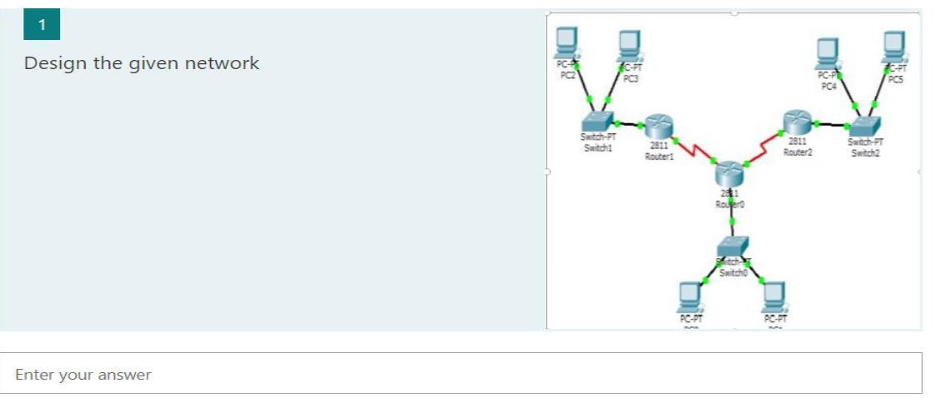

**Network Design:**

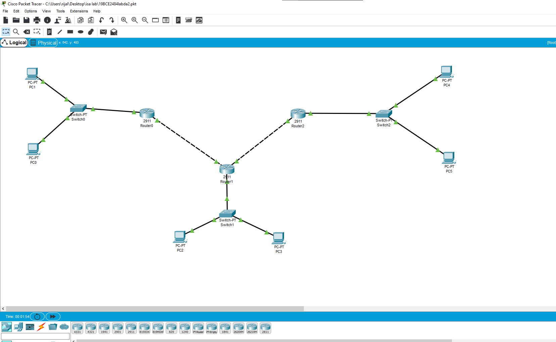

**Results:**

